

CHALLENGE NAME: [Stadium!!]   
DEV : [Abhinav]

CATEGORY: [OSINT]   
LEVEL: []

2025



CHALLENGE NAME: [Stadium!!]

**Challenge Description**:   
My friend wanted to play a cricket match; he told me to find the best place to play a game. So, I did. Can you identify the stadium where we played our match?

**Solution:**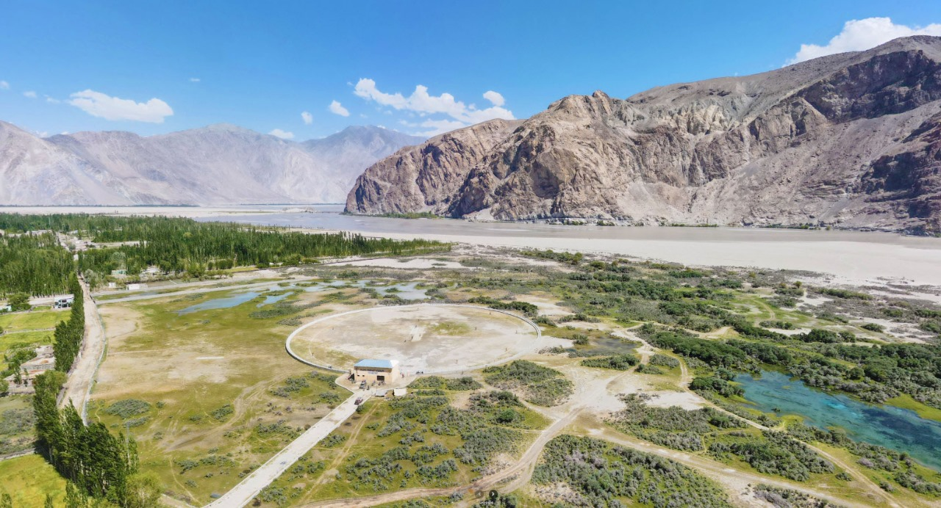

Just by using simple Google Lens you can get the stadium Name.  
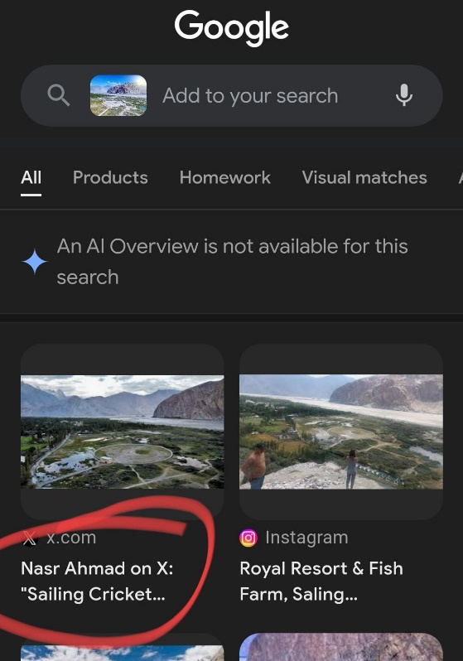  
Searching that on Maps to Get the full Name of the Stadium.

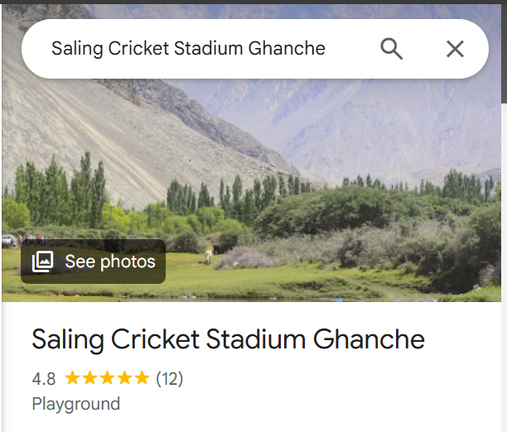

**Flag: VishwaCTF{Saling_Cricket_Stadium_Ghanche}**

DEV: [] **1**